Newton's 1st Law Introduction

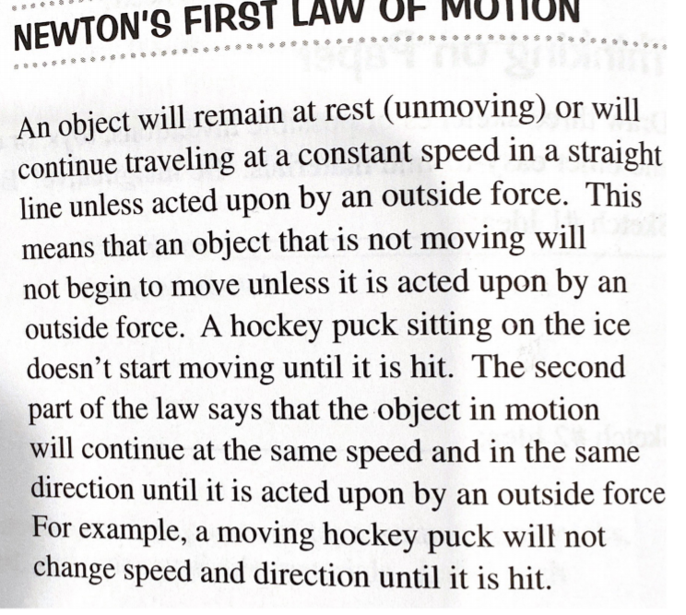

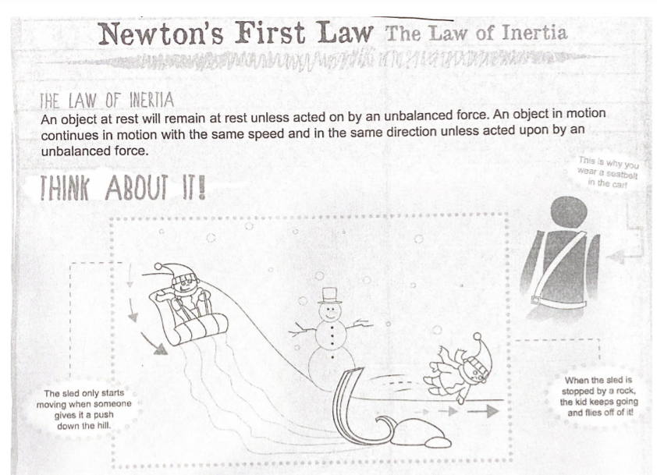

Answer in complete sentences.

1. In the picture above which objects are in motion? 1 person, snow, and sleds.
2. What is the unbalanced force in this picture? It is when the person is sledding down hill then he hits the rock and flies off the sled.
3. What happened to the sledder in this picture? In this picture the guy was coming down the hill, he hit the rock, and flew off the sled.
4. Describe an experience you have had relating to Newton's 1st Law. Once I tripped on the grass and started rolling down the hill and jumping and falling on my face.
5. What is Newton's 1st Law of Motion (also known as Law of Inertia) in your own words? The first law says that any object in motion will continue to move in the same direction and speed unless forces act on it.
6. Describe what happens if you are riding a skateboard and hit something (like a curb) with the front wheels. If I was riding on a skateboard and hit a curb body will keep moving forward and fly off your skateboard since the curb only stops the board not myself.
7. List and describe FIVE examples you see everyday that demonstrates Newton's 1st Law. Flying off a skateboard, flying off a snowboard when you hit a rock, flying off a bike then landing on a bike, flying off a scooter, and tripping on a rock.